A PROJECT SYNOPSIS ON
ONLINE E-COMMERCE PROSHOP

Six Months Industrial Training Report

1st page

DECLARATION

Sahil Dhingra declare that we are undertaken 6 months Software Training at Future Finders during a period from JAN 2024 to JULY 2024 in partial fulfilment of requirements for the award of degree of _____________________ at -__college name_. The work which is being presented in the training report submitted to Department of college name College is an authentic record of training work.

Sahil Dhingra

ACKNOWLEDGEMENT

I am highly grateful to the ________________, HOD CSE, University School of Engineering & Technology, college and University name (Mohali), for providing this opportunity to carry out the six month industrial training at _________________.

I would like to expresses my gratitude to other faculty members of Computer Science & Engineering department for providing academic inputs, guidance & encouragement throughout the training period.

The author would like to express a deep sense of gratitude and thank _ ___________Director/CEO of Company, without whose permission, wise counsel and able guidance, it would have not been possible to pursue my training in this manner.

The help rendered by Mr/Ms _______________, Supervisor (________________) for experimentation is greatly acknowledged.

Finally, I express my indebtedness to all who have directly or indirectly contributed to the successful completion of my industrial training.

Sahil Dhingra

CERTIFICATE

TO WHOM IT MAY CONCERN

I hereby certify that _______________(Name of the student), Roll No ___________ of B.Tech CSE, University School of Engineering & Technology, college name University(Mohali), has undergone six months industrial training from ____________ to ________________at our organization to fulfill the requirements for the award of degree of B.Tech. (Branch). He/She worked on _____________ project during the training under the supervision of __________________. During his/her tenure with us we found him/her sincere and hard working. We wish him/her a great success in the future.

Dated: 22-03-2022 Training In-charge: Gagan Sawhney

ABSTRACT

I have done my training at Futer Finders to improve my technical abilities in computer science.

ProShop is the buying and selling of services, or the transmitting of funds or data, over an electronic network, primarily the internet. These business transactions occur either as business-to-business, business-to consumer, consumer-to-consumer or consumer-to-business.

E-commerce shops have become part of our daily lives. Technological advancement has made it possible for people to sit in the convenience of their homes and still shop online without going to a physical shop. Indian have also joined the trend of e-commerce business, so this project is meant to design an ecommerce online shop so that the people in India will be able to purchase their goods and services online.

- INTRODUCTION TO COMPANY

Future Finders is a private incorporated on 6 June 2011. It is classified as non-govt. Company and registered at registrar of companies, Chandigarh its authorized share capital is Rs.900000 and its paid up capital is Rs.900000. It is involved in other computer related activities.
Complete IT solution provider
It is a leading software and web application development company, based in Mohali, which provides high quality comprehensive services to enterprises across a wide range of platforms and technologies are major areas of expertise in providing quality, cost effective software and web development.
Our focus is on understanding the diverse and mission critical need each of our clients to understand is to be able to deliver. The competence and experience of our company gives us a competitive edge by making sure we provide the best service and product to our clients. Our high quality standards enable us to deliver reliable and error free software applications despite the complexity.
Campus Edge
Campus Edge is a beneficial campus resource planning software that helps institutes in better functioning. The management, storage, and administration tasks get easier with our software. This ERP software will reduce our manual efforts and we will be able to maintain all our records more easily.
Believe in Empowering Innovation through Technology
Companies design bilateral and interactive online experiences for their clients with vast knowledge of the latest industry trends and technologies. Company solution and service are created keeping in mind our client’s requirements & expectations and international standard as well.
Company Expertise
Future Finders helps enterprises, whether established or startups, to build and grow customer-centric digital products for mobile and web. Our clients trust our experience of our decade and our expertise that we have gained after numerous successful deliveries in various fields. We delivered satisfactory services to our clients with an aim of helping their business in growing and reaching their organizational goals.

Our Vision
We visualize becoming the most trusted and respected IT service provider across the globe with our vibrant, dynamic, and value-based IT solutions that revolve around our clients, team, and international standards. Solitaire Infosys Pvt. Ltd. envisions becoming a reliable partner to all its clients and focusing on doing everything ethically and rightly. We are always open to accept our mistakes and have the nerve to do the necessary changes.

Our Goal
To grow and flourish as a leading company, to be admired globally to provide at most IT infrastructure and technical support services.
Delivering great work experience to our clients is what we aim at.
Future Finders Is an acclaimed IT service provider contributing its part in the development of many businesses around the globe. We socialize with our clients to get a superior cognizance of their business and requirements and help in fabricating websites and applications for their business. Founded in 2011 by a dynamic duo with the same aim and zeal, we have come a long way in satisfying our clients.
We are serving our clients with world-class services for more than seven years now. The clients are delivered with the best IT solutions after we have developed a great understanding of their business and requirements. Our team works on the client projects like its own and that is the reason why we hold the edge in the league.
With every project that we deliver, we deliver our respect, creativity, quality, transparency, and teamwork to our clients. We have the experience, expertise, and capabilities to enable organizations to accelerate their service processes in every possible way. We are known for our excellent customer satisfaction, cost-effectiveness, and innovative skills that are unparalleled.
Work
How is working in Future Finders special? Find out about the work culture and career growth opportunities in Future Finders at their office in Mohali. Follow them here and find out about their team, the fun and the work they do and stay updated with recruitment news and updates of solitaire Infosys.

Looking for in youth
As per the latest jobs posted by Future Finders they are regularly searching for job candidates with talents. They have the latest openings. They freely communicated and hired fresher and experienced candidates who have filled their profiles and applied to their jobs at youth4work. What solitaire Infosys are looking for in the talents they add in their team is generally beyond just degrees and certificates but is the real passion for work a youth does. Which is generally seen by the detailed profiles of youth and talent matrix of youth?
Future Finders is a leading software and web application development company, based in Mohali that provides high quality compressive services to enterprises across a wide range of platforms and technologies. Our major areas of expertise are in providing quality, cost effective software or web development.

TRAINING LANGUAGE DESCRIPTION

Introduction to MERN:

MERN is one of several variations of the MEAN stack (MongoDB Express Angular Node), where the traditional Angular.js frontend framework is replaced with React.js. Other variants include MEVN (MongoDB, Express, Vue, Node), and really any frontend JavaScript framework can work. Torrent, Google App Engine, Eve Online, Maya and iRobot machines.


History of MERN: -
Today, MEAN (MongoDB, Express.js, AngularJS (or Angular), and Node.js) is a free and open-source JavaScript software stack for building dynamic web sites and web applications.
Because all components of the MEAN stack support programs that are written in JavaScript, MEAN applications can be written in one language for both server-side and client-side execution environments.
Though often compared directly to other popular web development stacks such as the LAMP stack, the components of the MEAN stack are higher-level including a web application presentation layer and not including an operating system layer.
The acronym MEAN was coined by Valeri Karpov. He introduced the term in a 2013 blog post and the logo concept, initially created by Austin Anderson for the original MEAN stack LinkedIn group, is an assembly of the first letter of each component of the MEAN acronym.

MERN Stack Benefits:-
- Open Source Technology− Startups prefer MERN because it’s an open-source code that’s constantly being improved upon by tech experts from around the world. All the components of the MERN stack are open source, and thus you can use it to create robust web apps.
- Free Templates are available online− Free templates are available online, which will save you tons of time. It would have taken me at least three times as long to customize a theme compared to downloading an off-the-shelf solution. You’ll also get help from experts if you run into any issues along the way.
- Allow you to build fast − The MERN stacks rely on open-source technologies that developers can use freely, which means you don’t have to build everything from scratch. For example, if you want a blogging platform, chances are someone has already developed a popular framework like Wordpress.
- Easy to Use − The underlying technology gets so well documented that you can deploy it with ease. It’s simple to understand and use, making it an ideal choice for beginners learning web development.
- Full-Stack Development − MERN’s full-stack development approach means you’re responsible for building an application’s frontend and backend components. This approach draws on principles from both UI design and software engineering.
- Great Community Support − This set of technologies is backed by a solid community, making it easier to find answers to all sorts of technical questions that may come up. Thus when you’re unsure how something works or why there’s usually someone else who has already encountered (and fixed) similar problems.
- Offer Native Experience to the user −Native applications are more robust, secure and can provide a more compelling experience for users. So when start-ups develop mobile apps, they usually build them on top of hybrid frameworks like Ionic or React Native

Basic Concepts of MERN:-

MERN Stack: MERN Stack is a Javascript Stack that is used for easier and faster deployment of full-stack web applications. MERN Stack comprises of 4 technologies namely: MongoDB, Express, React and Node.js. It is designed to make the development process smoother and easier.
Each of these 4 powerful technologies provides an end-to-end framework for the developers to work in and each of these technologies play a big part in the development of web applications.
Getting started: First, create a new project folder. Then go to the project folder in command prompt/terminal and type below command to initialize a package.json file. (Make sure npm is installed)
npm init
A normal package.json file looks like this:
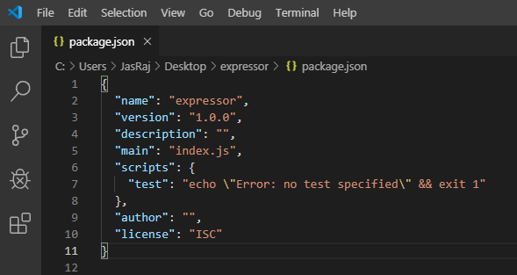

- MongoDB: Cross-platform Document-Oriented Database
MongoDB is a NoSQL database where each record is a document comprising of key-value pairs that is similar to JSON (JavaScript Object Notation) objects. MongoDB is flexible and allows its users to create schema, databases, tables, etc. Documents that are identifiable by a primary key make up the basic unit of MongoDB. Once MongoDB is installed, users can make use of Mongo shell as well. Mongo shell provides a JavaScript interface through which the users can interact and carry out operations (eg: querying, updating records, deleting records).

2. Express: Back-End Framework:
Express is a Node.js framework. Rather than writing the code using Node.js and creating loads of Node modules, Express makes it simpler and easier to write the back-end code. Express helps in designing great web applications and APIs. Express supports many middle wares which makes the code shorter and easier to write.

3. React: Front-End Library
React is a JavaScript library that is used for building user interfaces. React is used for the development of single-page applications and mobile applications because of its ability to handle rapidly changing data. React allows users to code in JavaScript and create UI components.

4. Node.js: JS Runtime Environment
Node.js provides a JavaScript Environment which allows the user to run their code on the server (outside the browser). Node pack manager i.e. npm allows the user to choose from thousands of free packages (node modules) to download.

INTRODUCTION TO PROJECT

Project Title and Description:
Project Title: Online E-Commerce ProShop
Project Description:-

Objective:-
- Manage Online Selling Costs in a strategic way
- Establish Deeper Business Relationships
- Provide a Unique Customer Experience
- Identify the right target audience
- Sell more

About the Project:-
In this MERN project, we will build an e-commerce website which is basically used for buying and selling of goods and services, or the transmitting of funds or data, over an electronic network, primarily the internet. These business transactions occur either as business-to-business, business-to-consumer, consumer-to-consumer or consumer-to-business.

Hardware Requirements:-
- Personal computer

Software Requirements:-
- NodeJS
- VS Code
- MongoDB Compass

Existing System Study:-

The purpose of Online E-commerce System is to automate the existing manual system by the help of computerized equipment ‘sand full-fledged computer software, fulfilling their requirements, so that their valuable data/information can be stored for a longer period with easy accessing and manipulation of the same. The required software and hardware are easily available and easy to work with.
The aim is to automate its existing manual system by the help of computerized equipment ‘sand full-fledged computer software, fulfilling their requirements, so that their valuable data/information can be stored for a longer period with easy accessing and manipulation of the same. Basically the project describes how to manage for good performance and better services for the clients.

METHODOLOGY/PLANNING OF WORK

Detailed description of each task in the methodology are documented, including the objectives, inputs, approach, relevant models, applicable tools and techniques, outputs, and any references. This process is to be reported in a proper organization, be it a word record or html pages.

The system will be implemented with a customer. This stage incorporates the showcasing of E-business system advancement administrations and the bringing of the deal to a close, trailed by the real usage.

Last touches and amendments to the approach are made in this stage. The dominant part of these corrections originates from encounters on the customer project. Test reports and any extra references are added to the strategy.

An E-commerce website requires appropriate strategy of successful design and implementation. Everything is required to plan from scratch to end of website. The e-commerce sector is seen the exponential growth thus a new option will easily part of this regatta of commercial website. The e-commerce website will feature the online shopping facility of various fashion products under a single web space. The proposed web application will allow business personnel to make their total business using it and increase their reachability thousands of times more than today they have, over the internet. It will allow multiple shopping vendors to sale their products online. The product management in the system will be done in the form of categories. The safety of information is the main requirement of the system and will be handling according to that. To formulate this project first task is to do is cost estimation. For probabilistic assessment of the project cost estimation is required. Cost estimation covers the accurate; estimations of cost and effort required for the project.

BACKGROUND OF THE STUDY
The traditional marketing and management of fashion industry is experiencing a revolution because of the emergence of e-commerce. Since the birth of e-commerce, businesses have been able to make use of the Internet in reducing costs associated with purchasing, managing supplier relationships, streamlining logistics and inventory, and developing strategic advantage and successful implementation of business re-engineering. E-commerce allows companies to improve communications within the supply chain and enhance service offering, thus providing chances for competitive differentiation. Fashion is a distinctive and often habitual trend in the style in which a person dress. It is the prevailing styles in behavior and the newest creations of textile designers.
Fashion design is influenced by cultural and social latitudes, and has varied over time and place. Fashion designers attempt to design clothes which are functional as well as aesthetically pleasing. They must consider who is likely to wear a garment and the situations in which it will be worn. Anthropology, the study of culture and human societies, studies fashion by asking why certain styles are deemed socially appropriate and others are not. A certain way is chosen and that becomes the fashion as defined by a certain people as a whole, so if a particular style has a meaning in an already occurring set of beliefs that style will become fashion. According to Ted Polhemus and Lynn Procter (2008), fashion can be described as a beautification. Fashion changes very quickly and is not affiliated with one group or area of the world but is spread out throughout the world wherever people can communicate easily with each other. The fashion industry is a product of the modern age. Historically, prior to the mid-19thcentury, most clothing was custom-made. It was handmade for individuals, either as home production or on order from dressmakers and tailors. By the beginning of the 20th century with the rise of new technologies such as the sewing machine, the rise of global capitalism and the development of the factory system of production, and the proliferation of retail outlets such as department stores clothing had increasingly come to be mass-produced in standard sizes and sold at fixed prices. Although the fashion industry developed first in Europe and America, as of 2014 it is an international and highly globalized industry, with clothing often designed in one country, manufactured in another, and sold world-wide. For example, an American fashion company might source fabric in China and have the clothes manufactured in Vietnam, finished in Italy, and shipped to a warehouse in the United States for distribution to retail outlets internationally. The fashion industry has long been one of the largest employers in the Kenya, and it remains so in the 21stcentury (from Mitumba sellers to custom made tailors). However, Kenyan government declined considerably as production increasingly shipped from overseas, especially from China. Instead, they encourage people to buy Kenyan made fashion products under the slogan

“Buy Kenya, Build Kenya.”
Because data on the fashion industry typically are reported for national economies and expressed in
terms of the industry’s many separate sectors, aggregate figures for
world production of textiles and clothing are difficult to obtain. However, by any measure, the clothing industry accounts for a significant share of world economic output. The fashion industry consists of four levels:
• The production of raw materials, principally fibers and textiles but also leather and fur.
• The production of fashion goods by designers, manufacturers, contractors, and others.
• Retail sales.
• Various forms of advertising and promotion.
These levels consist of many separate but interdependent sectors. These sectors are Textile Design and Production, Fashion Design and Manufacturing, Fashion Retailing, Marketing and Merchandising, Fashion Shows, and Media and Marketing. Each sector is devoted to the goal of satisfying consumer demand for apparel under conditions that enable participants in the industry to operate at a profit. Proshop falls under the retail category and truly need an ecommerce website to market and sell their products. The ecommerce system will make their daily operations and customer service efficient, error free and effective.

STATEMENT OF THE PROBLEM
Traditionally, customers are used to buying the products at the real, in other words, factual shops or supermarkets. It needs the customers to show up in the shops in person, and walk around different shopping shelves, and it also needs the owners of shops to stock, exhibit, and transfer the products required by customers. It takes labor, time and space to process these operations. Furthermore, the spread of the Covid-19 pandemic has caused a lot of changes in our lifestyle, people fearing to get outside their homes, transportation almost shut down and social distancing becoming all the more important. Big to small scale business that relied on the traditional incur a lot of consequence due to the lockdown issues. Some tend to more towards using social media platforms like Facebook to sell their product. However, the social media platforms have been beneficial for marketing purposes alone but leaves the whole task of customer and massive order management via direct messaging (DM), which takes a lot of time to respond to all customers. In addition, everyone tends to use social media, posing a great challenge to differentiate between scammers (fraudsters) and legit sellers.

THE SOLUTION
Proshop Store is an Online shopping system provides a solution to reduce and optimize these expenses. Authorized Customers do not need to go to the factual shops to choose, and bring the products they need by hands. They simply browse their Personal computers or cellphones to access shops, and evaluate the products description, pictures on the screen to choose products. In addition, the owners of the shop do not need to arrange or exhibit their stocks products. They just input the description, prices of products, and upload their pictures. Simply, both customers and shop owners do not need to touch the real products in the whole process of shopping, and management. In the end the logistic center will distribute the products required by customers, or products ordered by shop owners to their locations. The customers are able to track the status of their orders until delivery, after which they can leave a review of the type of service they received.
The payment and products’ quantity will be saved in database through the data flow.
These shopping, management and distribution processes greatly simplify and optimize the retail business.

SCOPE AND LIMITATION
Every project is done to achieve a set of goals with some conditions keeping in mind that it should be easy to use, feasible and user friendly. As the goal of this project is to develop an online fashion brochure system, this system will be designed keeping in mind the conditions (easy to use, feasibility and user friendly) stated above. It may help in effective and efficient order management. In every shot time, the collection will be obvious, simple and sensible. It is very possible to observe the customer potentials and purchase patterns because all the ordering history is store in the database. It is efficient managing all the operations of an online store within a single platform. The project aims to automate the business process of La BELLE Fashion store. The proposed project would cover:
Customer Side
• Customer can view/search products without login.
• Customer can also add/remove product to cart without login (if customer try to addsame product in cart. It will add only one)
• When customer try to purchase product, then he/she must login to system.
• After creating account and login to system, he/she can place order.
• If customer click on pay button, then their payment will be successful and their order will be placed.
• Customer can check their ordered details by clicking on orders button.
• Customer can see the order status (Pending, Confirmed, Delivered) for each order
• Customer can Download their order invoice for each order
• Customer can send feedback to admin (without login)

Administrator Side
Admin can provide username, email, password and your admin account will be created.
• After login, there is a dashboard where admin can see how many customers is registered, how many products are there for sale, how many orders placed.
• Admin can add/delete/view/edit the products.
• Admin can view/edit/delete customer details.
• Admin can view/delete orders.
• Admin can change status of order (order is pending, confirmed, out for delivery, delivered)
• Admin can view the feedbacks sent by customers Additionally, if customer places order and admin deleted that user (fraud detection), then their orders will automatically be deleted. Suppose one (1) customer places four (4) products order and admin deleted two (2) products from website, then that two-product order will also be deleted and other two will be there. Also, if user click on purchase button without having products in their cart, then website will ask to add product in cart first. On the contrary, designing web applications is characterized by some constraints and limitations. Developers are limited to a small set of graphical widgets for use in presenting a user interface. Web-based applications require high investment in software, as well as maintenance costs for the software and personnel for software administration. In this study, verification of credentials for membership cannot be done. Besides, there is a payment page although just for demo. Customers are advised to fill in pseudo details (DONT FILL YOUR ORIGINAL CARD DETAILS THERE). By the way, website do not save these details.

IMPORTANCE OF ONLINE SHOPPING
Ling, said that customers can take enjoy online shopping for 24 hour per day. Consumers can purchase any goods and services anytime at everywhere. Online shopping is user friendly compare to in store shopping because consumers can just complete his requirements just with a click of mouse without leaving their home. Online shopping has some advantages like below

• Save the Time of the consumers.
• They can purchase any time anywhere
• They can compare the price with the others retailers very easily.
• Compare the advertising price and actual price
• They can easily track their product
• They can use cash back policy
• They can purchase the product from the foreign marketers

DESIGN OF SOLUTION

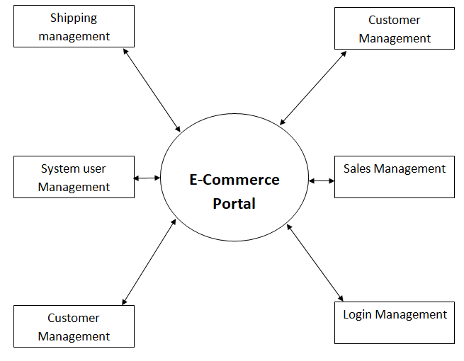

Functional Requirements
The following is the desired functionality of the new system. The proposed project would cover:
Customer Module
• Customer can view/search products without login.
• Customer can also add/remove product to cart without login (if customer try to add same product in cart. It will add only one)
• When customer try to purchase product, then he/she must login to system.
• After creating account and login to system, he/she can place order.
• If customer click on pay button, then their payment will be successful and their order will be placed.
• Customer can check their ordered details by clicking on orders button.
• Customer can see the order status (Pending, Confirmed, Delivered) for each order
• Customer can Download their order invoice for each order
• Customer can send feedback to admin (without login)

Admin Module
• Admin can provide username, email, password and your admin account will be created.
• After login, there is a dashboard where admin can see how many customers is registered, how many products are there for sale, how many orders placed.
• Admin can add/delete/view/edit the products.
• Admin can view/edit/delete customer details.
• Admin can view/delete orders.

SCREENSHOTS

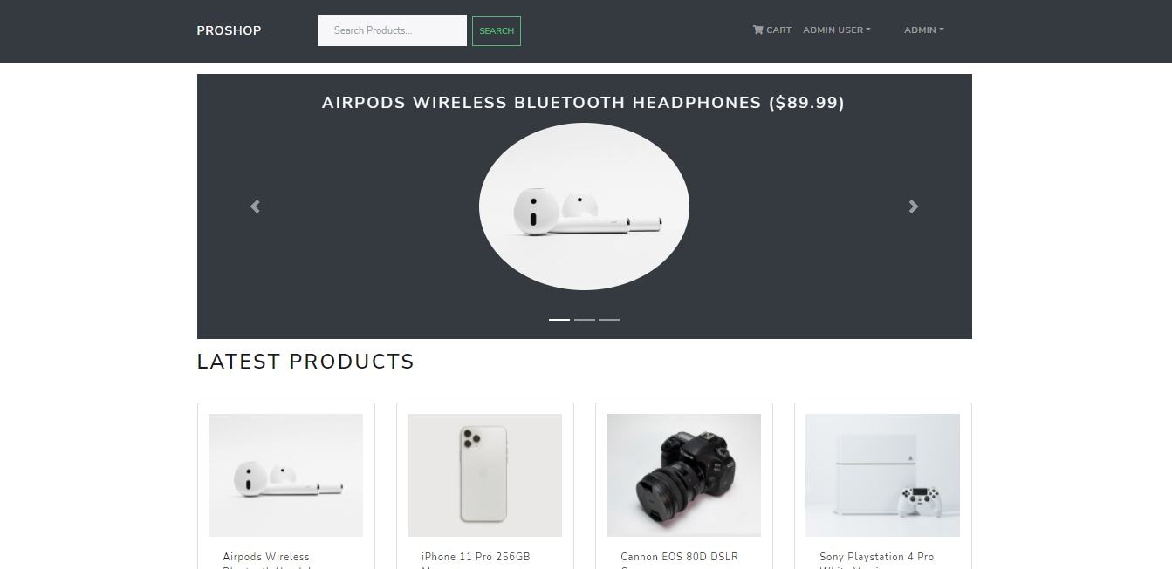
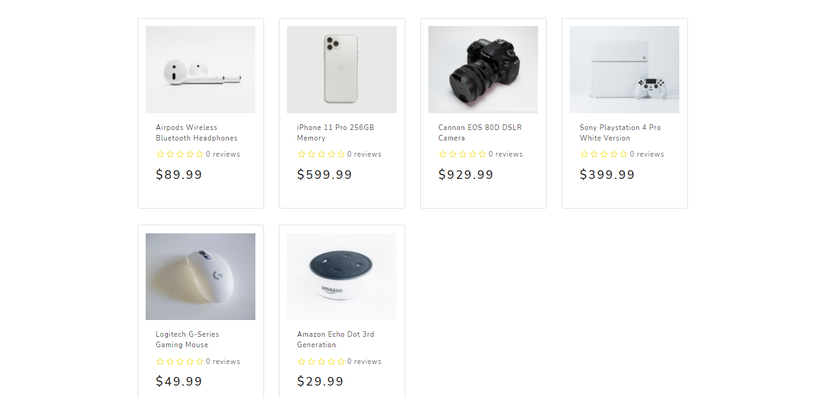

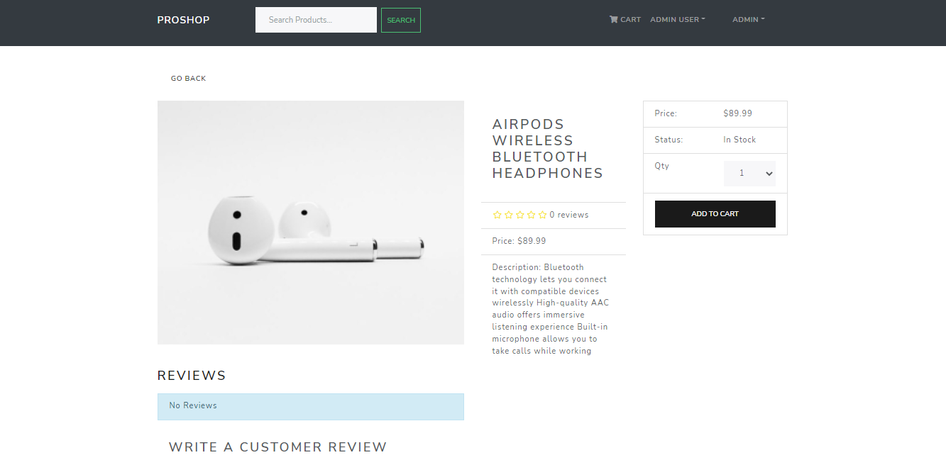

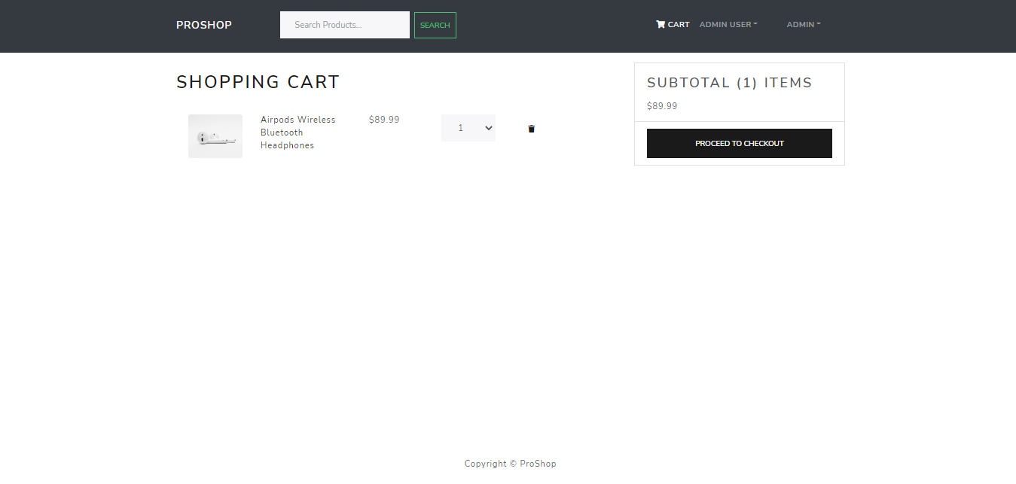

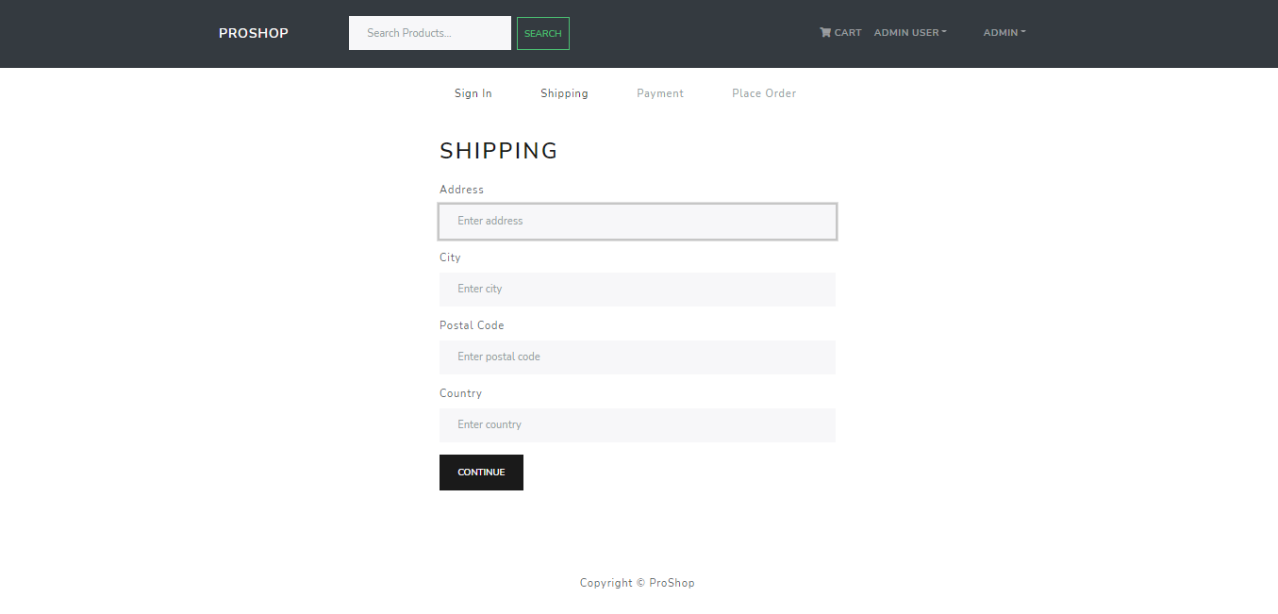

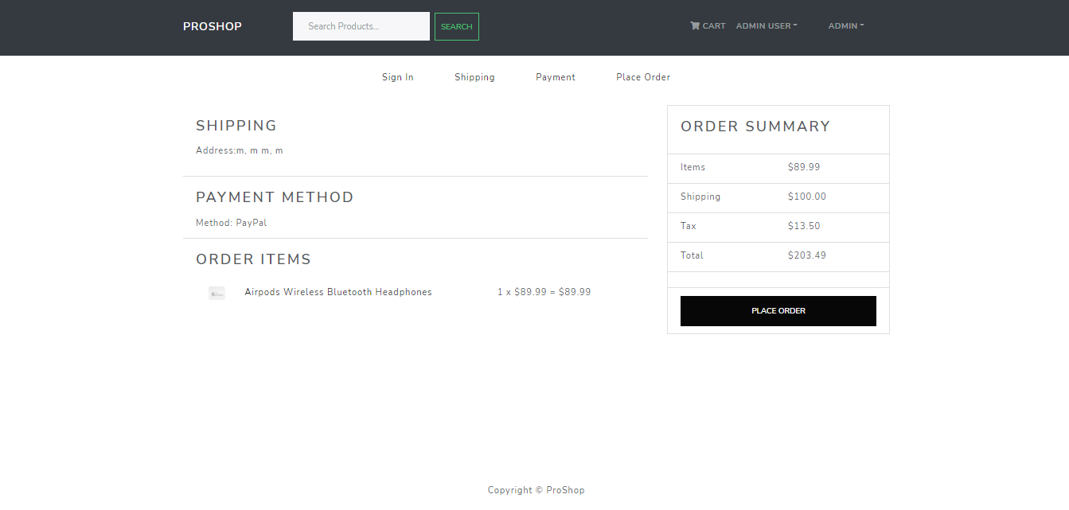

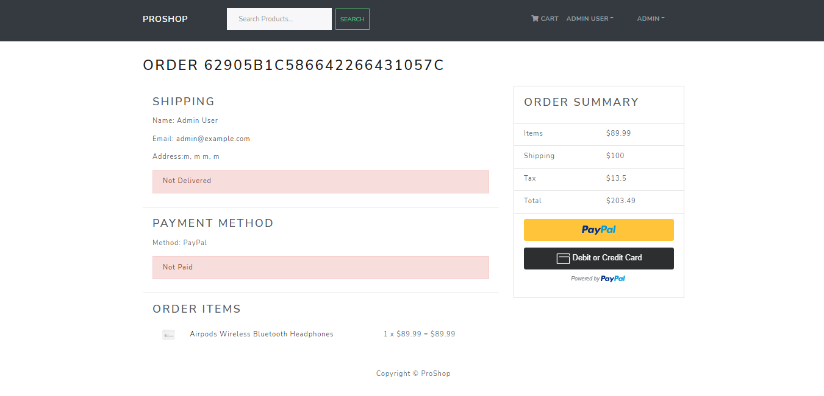

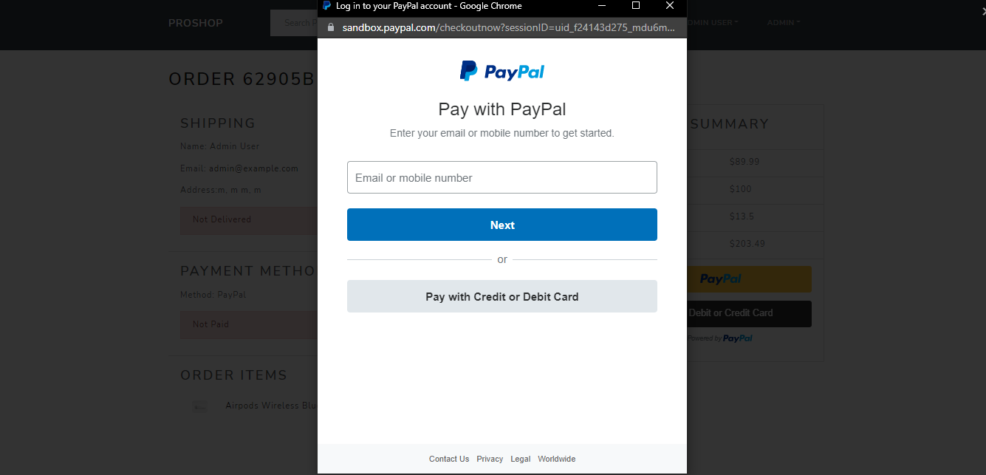

ADMIN PANEL

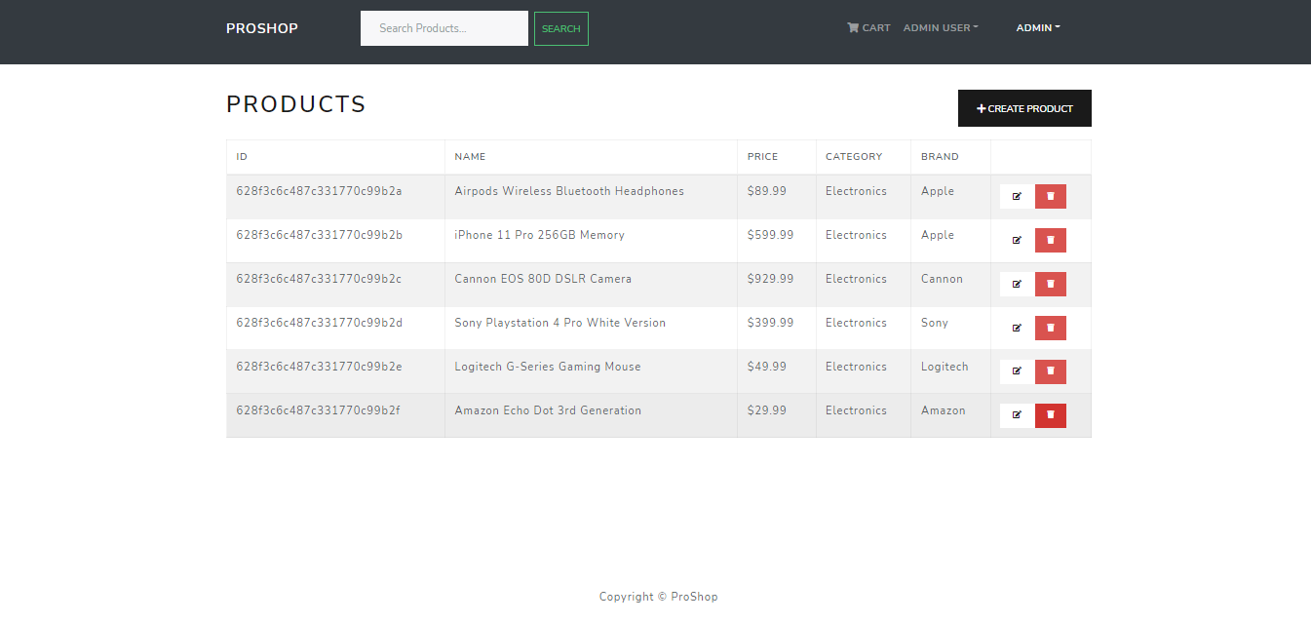

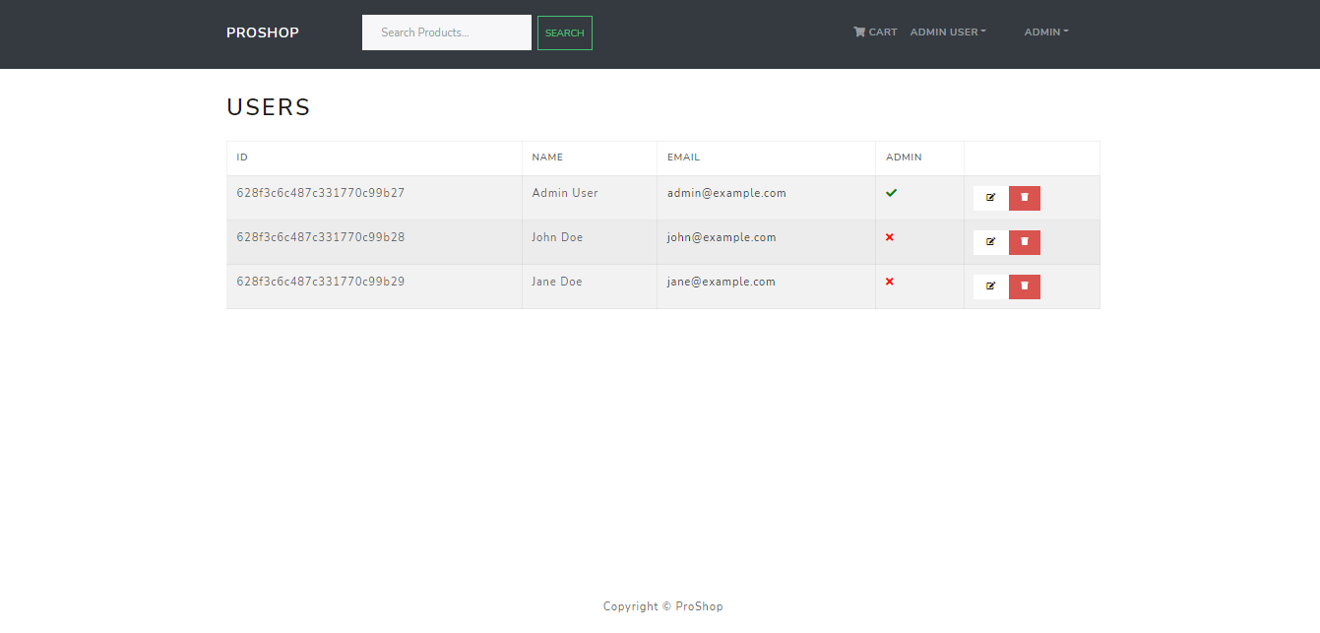

LOGIN/ SIGNUP

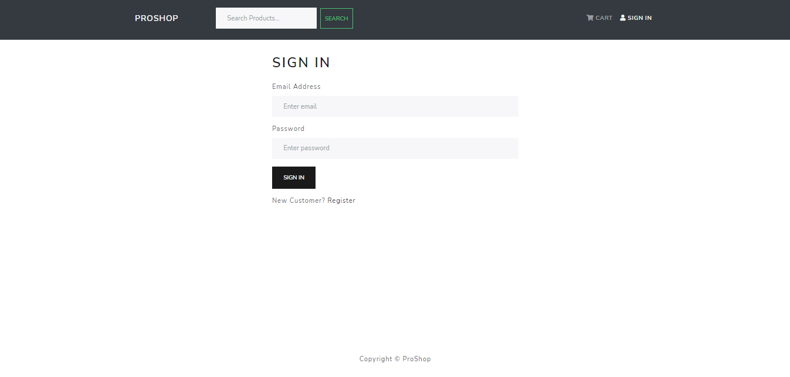

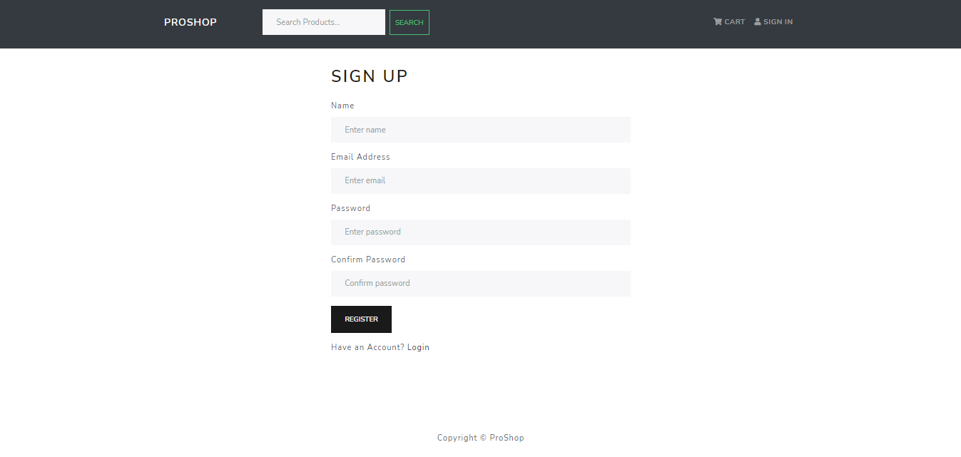

CONCLUSION:

It is concluded that the website is working and all its core function are also working. Any bug that I was able to get, I removed it and will keep trying to improve this application.

Making this project is one of the challenging works, which I did as Good I can and this website will keep getting better with future updates.

Future Scope:

Future scope of this project is great as there are many things that can be added to this website that can make this application better than it already is. Future update also ensures that user is getting free user experience.

Updating website for latest features in code is also a task that must be done.

